**GOVERNMENT COLLEGE OF ENGINEERING-ERODE**

**NAAN MUDHAVAN IBM – PROJECT**

**ELECTRONICS AND COMMUNICATION ENGINEERING**

**TAMILNADU[TN] MARGINAL WORKERS ASSESSMENT**

**MENTOR**

**Dr.M.Sathiyakala**

**Department of Information Technology(IT)**

**NAME NM-ID**

**GOWTHAM.R au731121106016**

**TAMILNADU[TN] MARGINAL WORKERS ASSESSMENT**

**Project Introduction:**

The project involves analysing the demographic characteristics of marginal workers in Tamil Nadu based on their age, industrial category, and sex. The objective is to perform a socioeconomic analysis and create visualizations to represent the distribution of marginal workers across different categories. This project includes defining objectives, designing the analysis approach, selecting appropriate visualization types, and performing the analysis **using Python and data visualization libraries.**

**Objectives:**

**Identification of Marginalized Groups:**

To identify specific marginalized groups within the marginal worker population, such as women, Scheduled Castes, Scheduled Tribes, and other vulnerable **communities.**

**Economic and Social Indicators:**

To assess the economic well-being of marginal workers by measuring income levels, wage disparities, and access to social security benefits.

To evaluate the living conditions, healthcare access, and education status of marginal workers and their families.

**Labor Rights and Welfare Programs:**

To examine the extent to which marginal workers are aware of their labour rights and the utilization of existing labour welfare programs.

To identify barriers that prevent marginal workers from accessing and benefiting from these programs.

**Design Thinking:**

* 1. Project Objectives: Objectives are defined such as analysing marginal worker demographics, understanding age and gender distribution, and exploring industrial categories.
  2. Analysis Approach: Analysis can be done by steps to extract, clean, and analyse the dataset to derive insights.
  3. Visualization Selection: By determining suitable visualization types (e.g., bar charts, pie charts, heatmaps) to represent demographic distributions effectively.

**Visualization:**

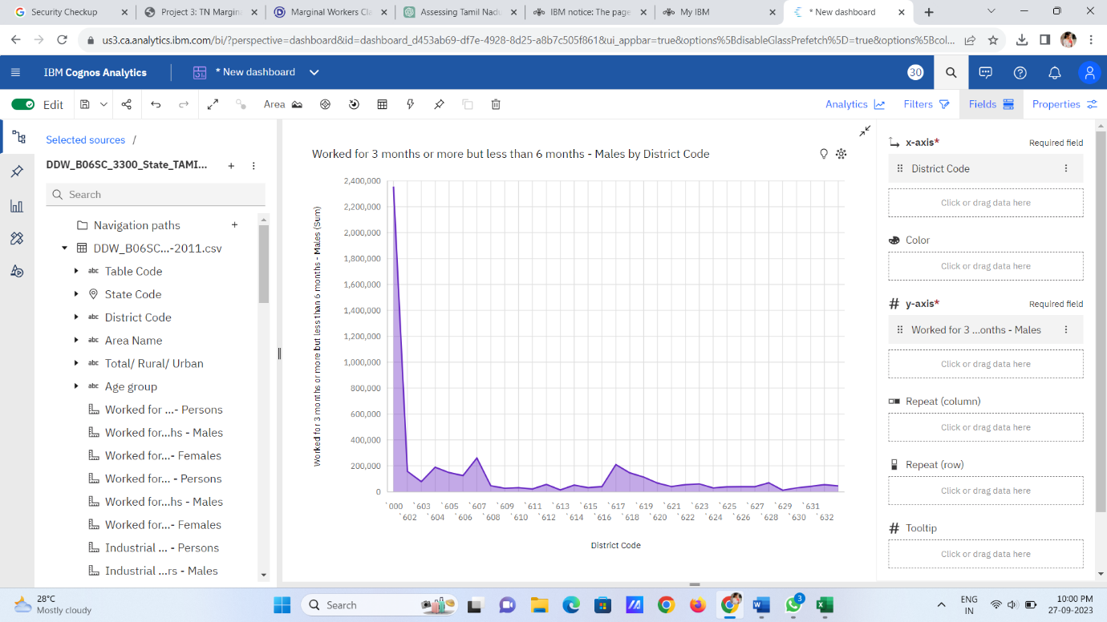

**STEPS INVOLVED DURING ANALYSIS:**

**1.Empathize with the Marginal Workers:**

This can be done by understanding the lives, challenges, and aspirations of Tamil Nadu's marginal workers. This may involve field visits, interviews, surveys, and ethnographic research.

**2 Problem Definition:**

Based on the research and insights from the field, the problem or challenges faced by marginal workers can be defined.

**3.Prototyping:**

These could be physical prototypes, process flowcharts, or even role-playing scenarios. By testing and iterate on these prototypes with feedback from marginal workers and other stakeholders would help to solve the problems.

**4.Testing:**

Implementing prototypes in real-life situations or simulate scenarios by gathering feedback and data on their effectiveness and by gathering insights from how they are received and used.

**5.User-Centered Solutions:**

By keeping the needs and perspectives of the marginal workers at the center of the solutions to ensure that any innovations directly address their concerns and improve their lives.

**6.Communication and Advocacy:**

By Sharing the progress of the project and the innovative solutions with the public, policymakers, and organizations that can support or replicate efforts.

**7.Evaluation:**

Continuously evaluating the impact of the project by using both quantitative and qualitative data to measure the effectiveness of innovations and their contribution to the well-being of marginal workers in Tamil Nadu.

**8.Documentation:**

Documenting design thinking process includes research, prototyping, testing, and results.

Applying design thinking to a project involving Tamil Nadu's marginal workers can lead to more effective and sustainable solutions that genuinely address their needs and improve their quality of life.

**9.Reporting:**

Report can be made by summarizing the analysis, including key findings, conclusions, and any recommendations.

**Analysis of Marginal workers:**

 As per data from [https://tn.data.gov.in/resource/marginal-workers-classified-age-industrial-category-and-sex-scheduled-caste-2011-tamil](https://tn.data.gov.in/resource/marginal-workers-classified-age-industrial-category-and-sex-scheduled-caste-2011-tamil%20 ). The classification of the working population is based on the part time workers. Part time working population is called Marginal Working Population.

The Marginal Working population do not work through the entire year but works on the seasonal basis or on a particular periods of year only. Marginal workers were those who worked any time at all in the year preceding the enumeration but did not work for a major part of the year, i.e., those who worked for less than 183 days (or six months).

**DATA VISUALIZATION OF TOTAL MARGINAL WORKERS IN TAMILNADU:**

Analysis of the marginal workers in Tamil Nadu has been visualized and can be viewed using the following link and it can viewed as in image[Fig:1]: <https://us3.ca.analytics.ibm.com/bi/?perspective=dashboard&pathRef=.my_folders%2FPIECHART-MALE%2BANALYSIS&action=view&mode=dashboard&subView=model0000018b40fdb107_00000000>

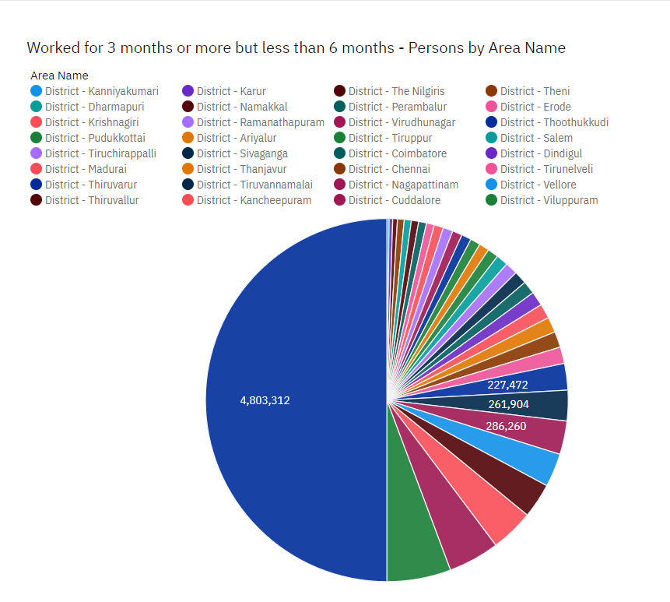

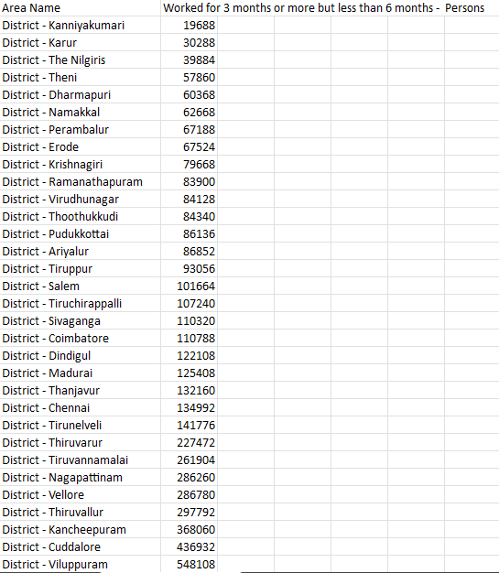

Fig :1

**FINDINGS:**

* Viluppuram[260,252] has the most marginal working population among the states in Tamil Nadu.
* Kanyakumari[11,544] has the least count in marginal workers among the states in Tamil Nadu.

**The marginal working population can be classified as following:**

**Cultivators:**

A person was considered as cultivator if he or she was engaged either as employer, single worker or family worker in cultivation of land owned or held from government of held from private persons or institutions for payment in money, kind or share of crop. Cultivation included supervision or direction of cultivation. A person who had given out his/her land to another person or persons for cultivation or money, kind or share of crop and who did not even supervise or direct cultivation of land was not treated as cultivator.

The visualization of this data can be viewed by the following link and can also be viewed as image[Fig:2]:

<https://us3.ca.analytics.ibm.com/bi/?perspective=dashboard&pathRef=.my_folders%2FBARVIEW-CULTIVATORS&action=view&mode=dashboard&subView=model0000018b40fdb107_00000000>

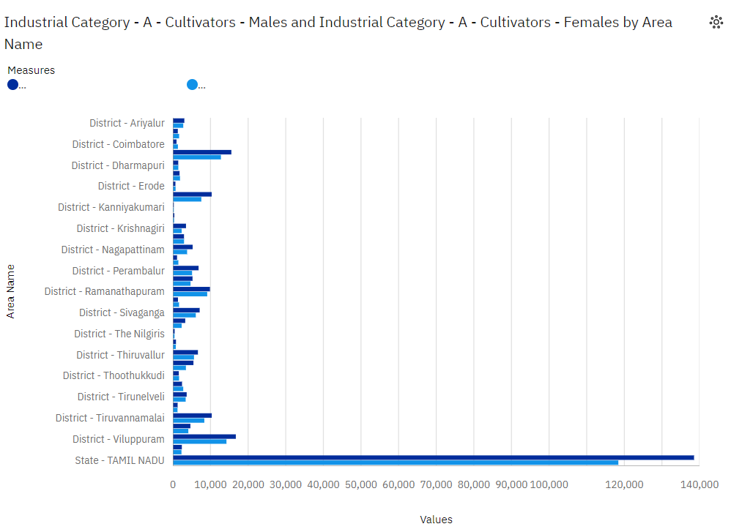

**FIG:2**

**Findings:**

* Viluppuram [16,600] has the most female cultivators among the states in Tamil Nadu.
* Viluppuram[14,240] has the least female cultivators among the states in Tamil Nadu.
* Kanyakumari[240] has the most male cultivators among the states in Tamil Nadu.
* Kanyakumari[188] has the least male cultivators among the states in Tamil Nadu.

**Agricultural Labours:**

A person who worked in another person's land for wages in cash, kind or share was regarded as an agricultural labour. Such a person had no risk in cultivation but merely worked in another person's land for wages. An agricultural labourer had no right of lease or contract on land on which he worked.

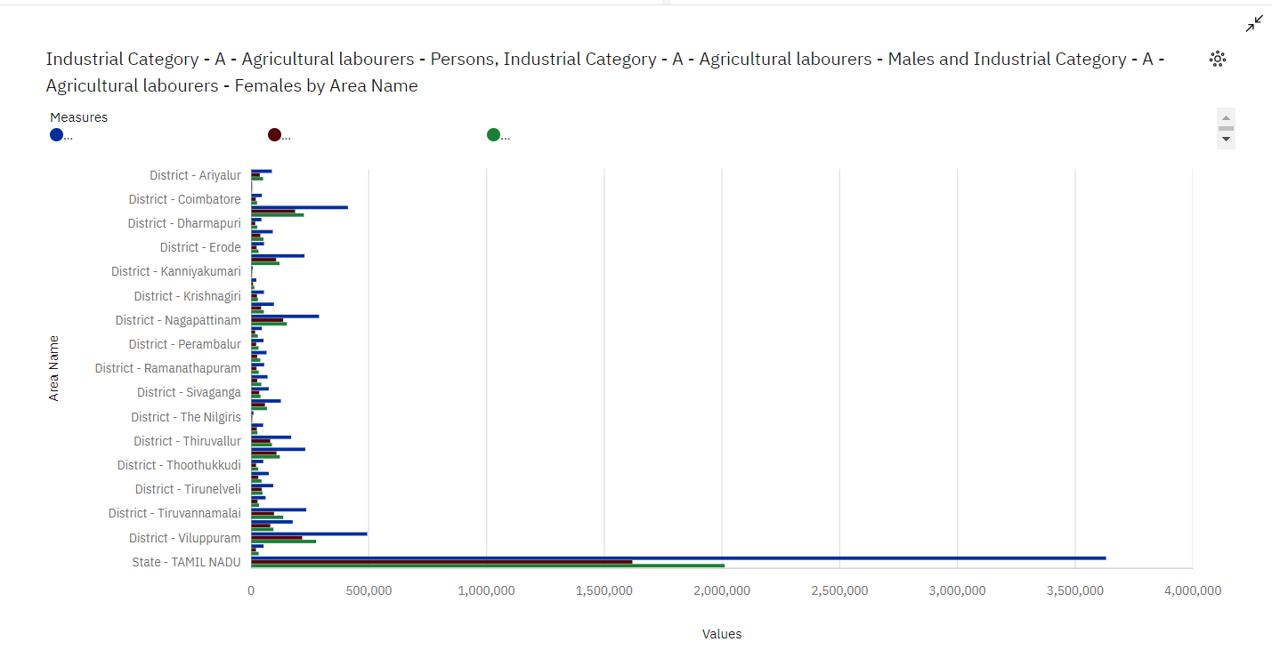

**Findings:**

* Viluppuram[2,76,244] has the most female agricultural workers among the states in Tamil Nadu.
* Chennai[1,224] has the least female agricultural workers among the states in Tamil Nadu.
* Viluppuram[2,16,972]has the most male cultivators agricultural workers among the states in Tamil Nadu.
* Chennai[2,052]has the least male cultivators agricultural workers among the states in Tamil Nadu.

**INDUSTRIAL CATEGORIES-A:**

Plantations are farms specializing in cash crops, usually mainly planting a single crop, with perhaps ancillary areas for vegetables for eating and so on. Livestock are the domesticated animals raised in an agricultural setting in order to provide labour and produce diversified products for consumption

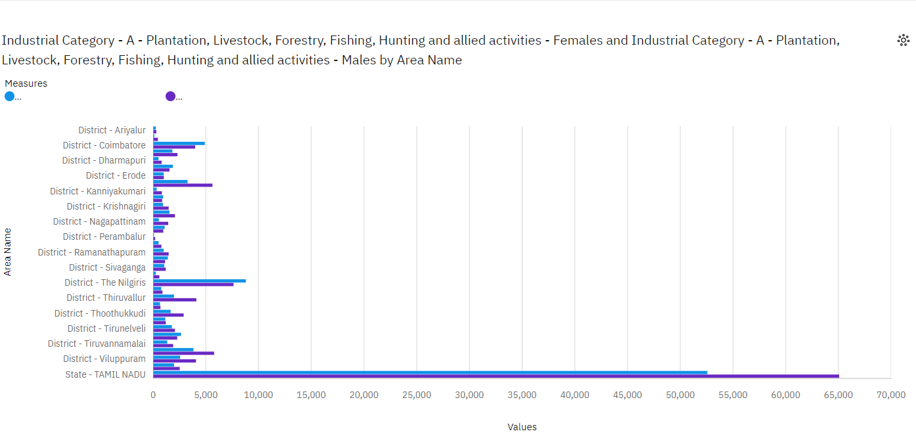

**Findings:**

* Nilgiri [8800]has the most female agricultural workers among the states in Tamil Nadu.
* Perambalur [64]has the least female cultivators agricultural workers among the states in Tamil Nadu.
* Nilgiri [7,624]has the most male cultivators agricultural workers among the states in Tamil Nadu.
* Perambalur [192]has the least male cultivators agricultural workers among the states in Tamil Nadu.

**INDUSTRIAL CATEGORIES-B [Mining and Quarrying]:**

Mining is the process of extracting buried material below the earth surface. Quarrying refers to extracting materials directly from the surface. In mining and quarrying, water is used and gets polluted in a range of activities, including mineral processing, dust suppression, and slurry transport.

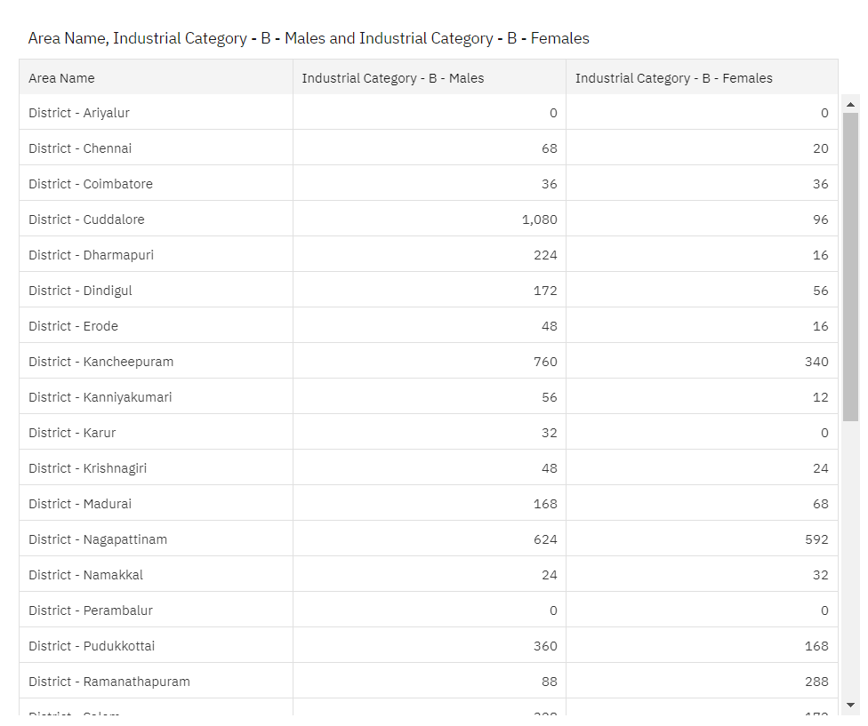

**Findings:**

* Kancheepuram has the most female workers in industrial category-B among the states in Tamil Nadu
* Kaur has the least female workers industrial category-B among the states in Tamil Nadu.
* Cuddalore has the most male workers in industrial category-B among the states in Tamil Nadu.
* Ariyalur has the least male workers in industrial category-B among the states in Tamil Nadu.

**INDUSTRIAL CATEGORIES-C [Manufacturing]:**

A manufacturing job involves the creation of new products either from raw materials or by assembling different components through physical, chemical or mechanical means. Manufacturing can exist on a large scale for items such as phones, cars, computers and food and beverages.

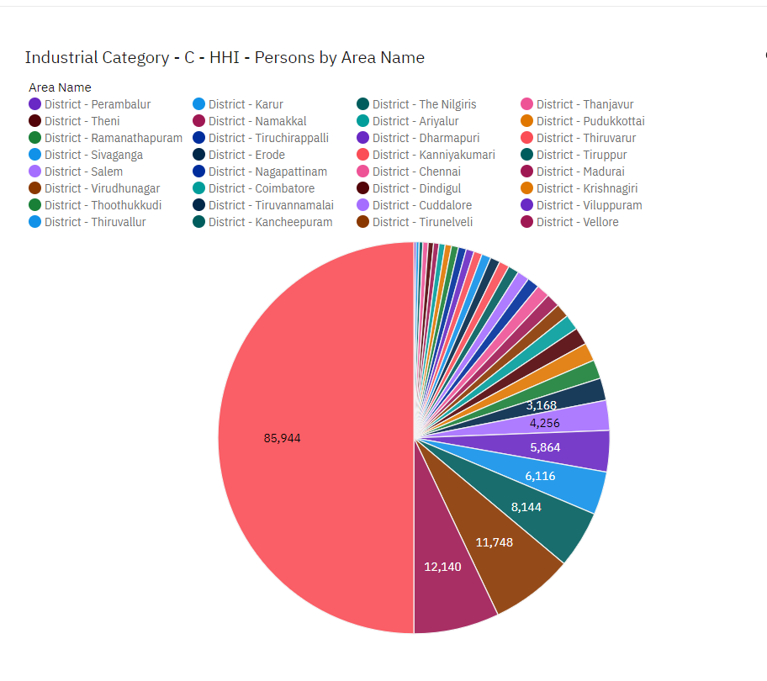

**Findings:**

* Vellore has the most population in industrial category -C.
* Perambalur has the least population in industrial category -C

**INDUSTRIAL CATEGORIES-D and E :[Electricity ,Gas, Steam and air conditioning]:**

HVACR technicians install, maintain, and repair heating, cooling, and refrigeration systems. Heating, air conditioning, and refrigeration mechanics and installers—often called HVACR technicians—work on heating, ventilation, cooling, and refrigeration systems that control the temperature and air quality in buildings.

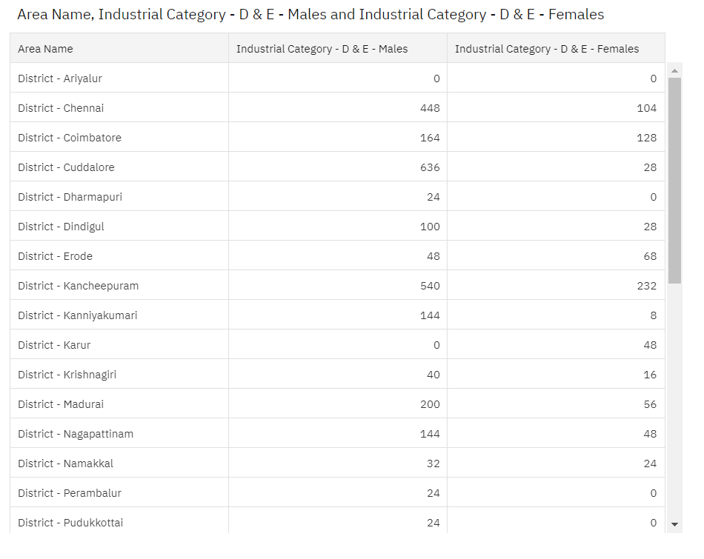

**Findings:**

* Cuddalore has the most population in industrial category – D&E.
* Ariyalur has the least population in industrial category – D

**INDUSTRIAL CATEGORIES-F[Construction]:**

A construction worker is someone who is employed as part of a construction crew and will perform many tasks that often involve physical labour on construction sites. However, there are plenty of roles that don't involve being on a construction site.

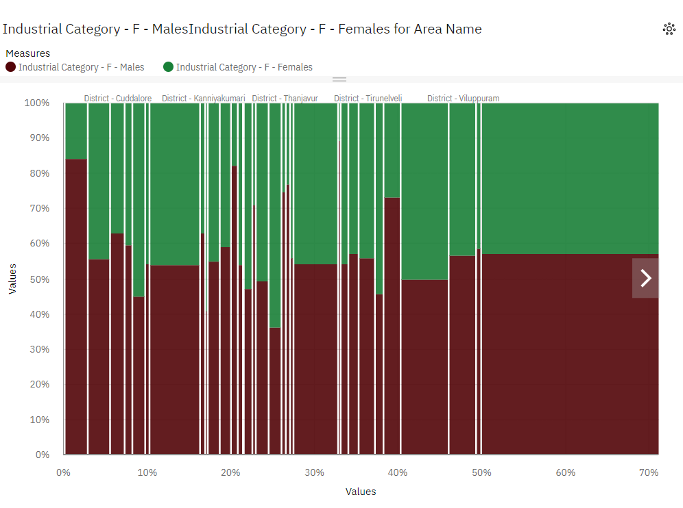

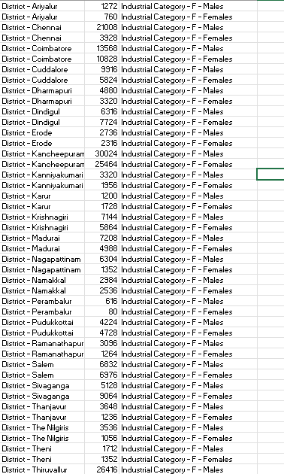

**FINDINGS :**

* Kancheepuram has the most female workers in industrial category-F among the states in Tamil Nadu
* Perambalur has the least female workers industrial category-F among the states in Tamil Nadu.
* Kancheepuram has the most male workers in industrial category-F among the states in Tamil Nadu.
* Perambalur has the least male workers in industrial category-F among the states in Tamil Nadu.

**Further the analysis is done based on the workers age classification of workers involved in industrial categories:**

**INDUSTRIALCATEGORIES-A [Plantation,livestock,forestry,hunting,fishing and hunting activities]:**

Plantations are farms specializing in cash crops, usually mainly planting a single crop, with perhaps ancillary areas for vegetables for eating and so on. Livestock are the domesticated animals raised in an agricultural setting in order to provide labour and produce diversified products for consumption.

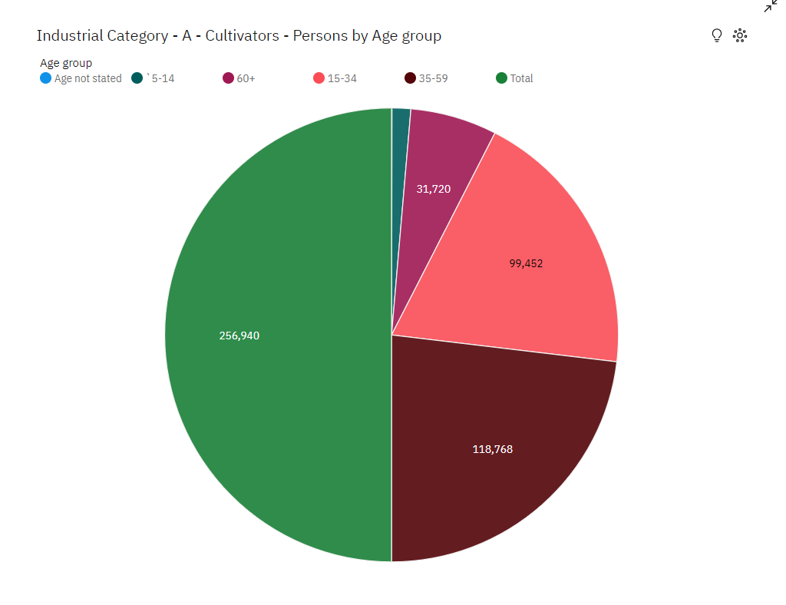

**Findings:**

* Workers with age group between [35-59] are the highest among all the

workers in industrial category-A.

**INDUSTRIAL CATEGORIES-B [Mining and Quarrying]:**

Mining is the process of extracting buried material below the earth surface. Quarrying refers to extracting materials directly from the surface. In mining and quarrying, water is used and gets polluted in a range of activities, including mineral processing, dust suppression, and slurry transport.

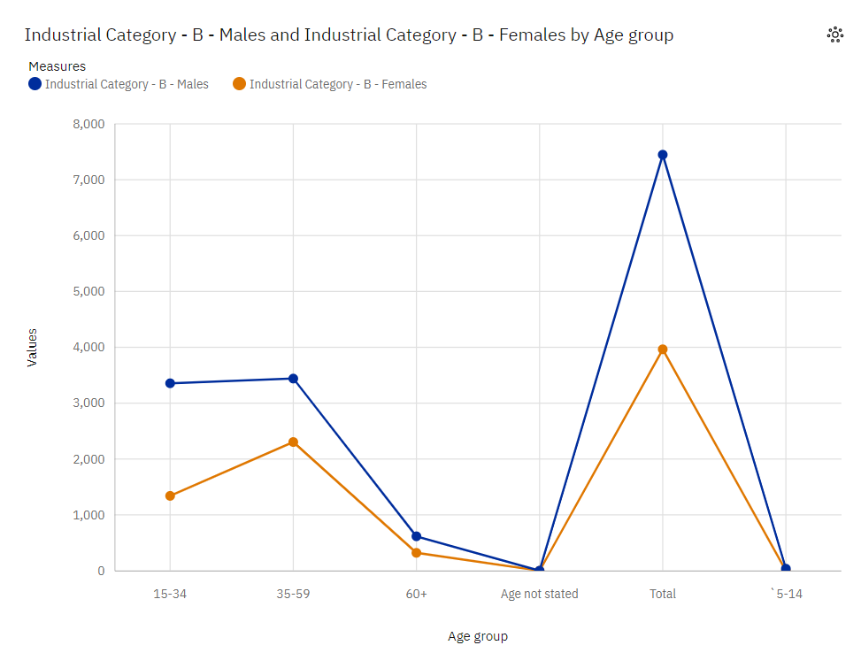

**Findings:**

* Workers with age group between [35-59] are the highest among all the workers in industrial category-B.
* Workers with age group between [60+] are the lowest among all the workers in industrial category-B.

**INDUSTRIAL CATEGORIES-C [Manufacturing]:**

A manufacturing job involves the creation of new products either from raw materials or by assembling different components through physical, chemical or mechanical means. Manufacturing can exist on a large scale for items such as phones, cars, computers and food and beverages.

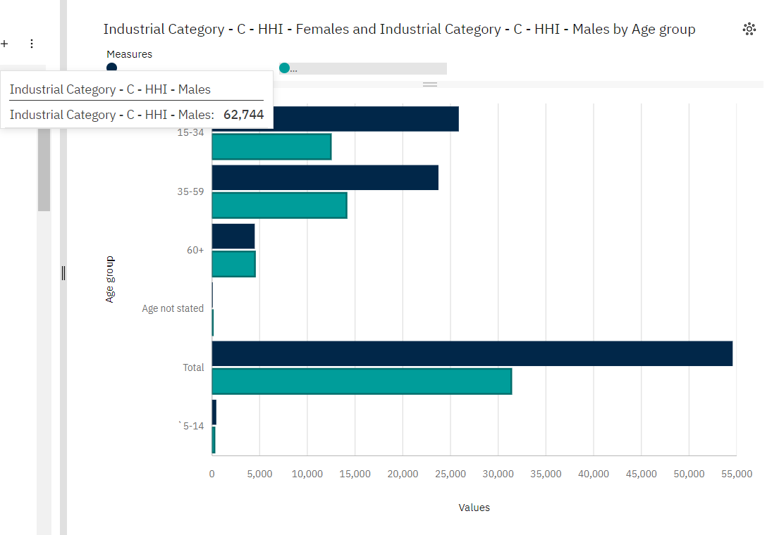

**Findings:**

* Workers with age group between [15-34] are the highest among all the workers in industrial category-C
* Workers with age group between [5-14] are the lowest among all the workers in industrial category-C

**INDUSTRIAL CATEGORIES-D and E :[Electricity ,Gas, Steam and air conditioning]:**

HVACR technicians install, maintain, and repair heating, cooling, and refrigeration systems. Heating, air conditioning, and refrigeration mechanics and installers—often called HVACR technicians—work on heating, ventilation, cooling, and refrigeration systems that control the temperature and air quality in buildings.

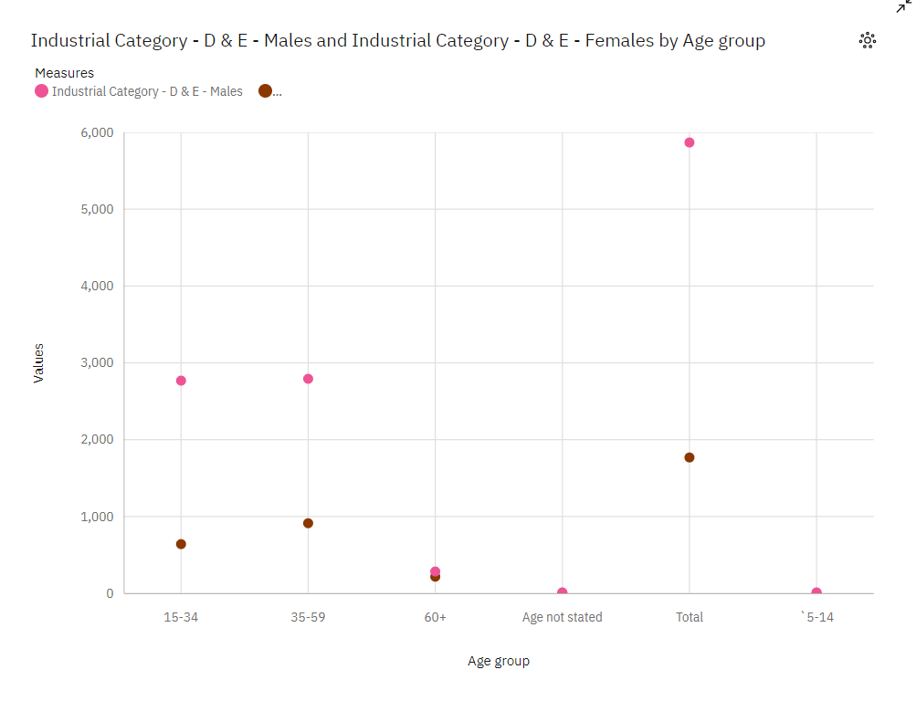

**Findings:**

* Workers with age group between [35-59] are the highest among all the workers in industrial category-D&E
* Workers with age group between [5-14] are the lowest among all the workers in industrial category-D&E

**INDUSTRIAL CATEGORIES-F[Construction]:**

A construction worker is someone who is employed as part of a construction crew and will perform many tasks that often involve physical labour on construction sites. However, there are plenty of roles that don't involve being on a construction site.

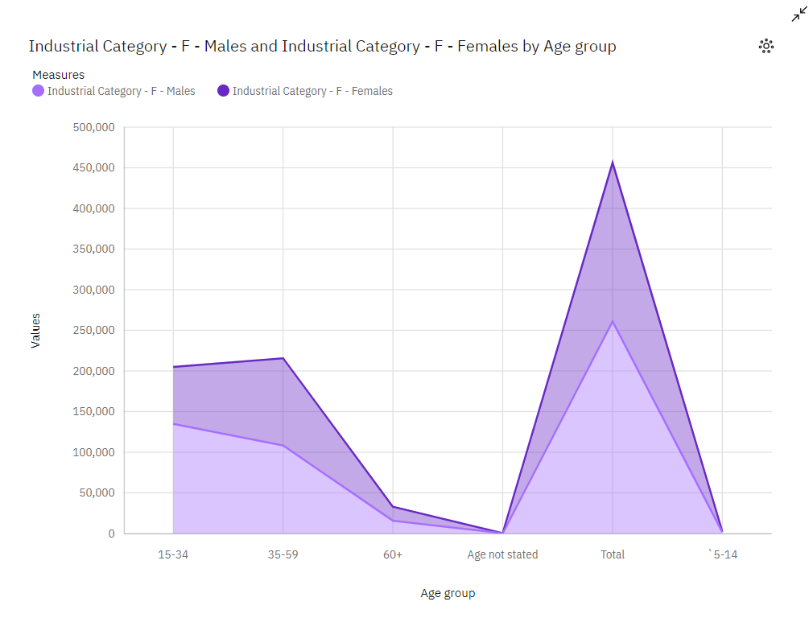

**FINDINGS:**

* Workers with age group between [35-59] are the highest among all the workers in industrial category-F
* Workers with age group between [60+] are the lowest among all the workers in industrial category-F

**INDUSTRIAL CATEGORY-G**:

Wholesale trade consists of purchasing and selling goods, generally to retailers, professional (industrial or commercial) users or authorities, or to other wholesalers or intermediaries, regardless of the quantities sold.

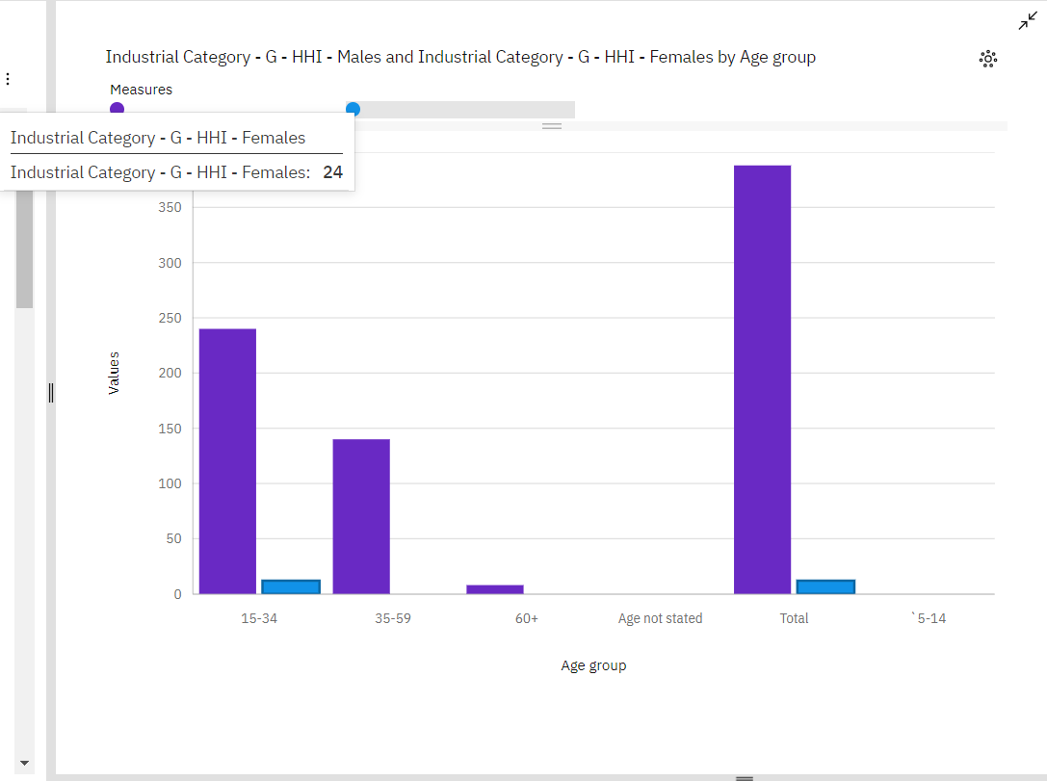

**FINDINGS:**

* Workers with age group between [15&34] are the highest among all the workers in industrial category-G
* Workers with age group between [60+] are the lowest among all the workers in industrial category-G

**INDUSTRIAL CATEGORY-H:**

Transportation workers in marginal areas face unique challenges and play crucial roles in ensuring that people in these regions have access to essential services and goods. Marginal areas can include remote, rural, or underserved locations.

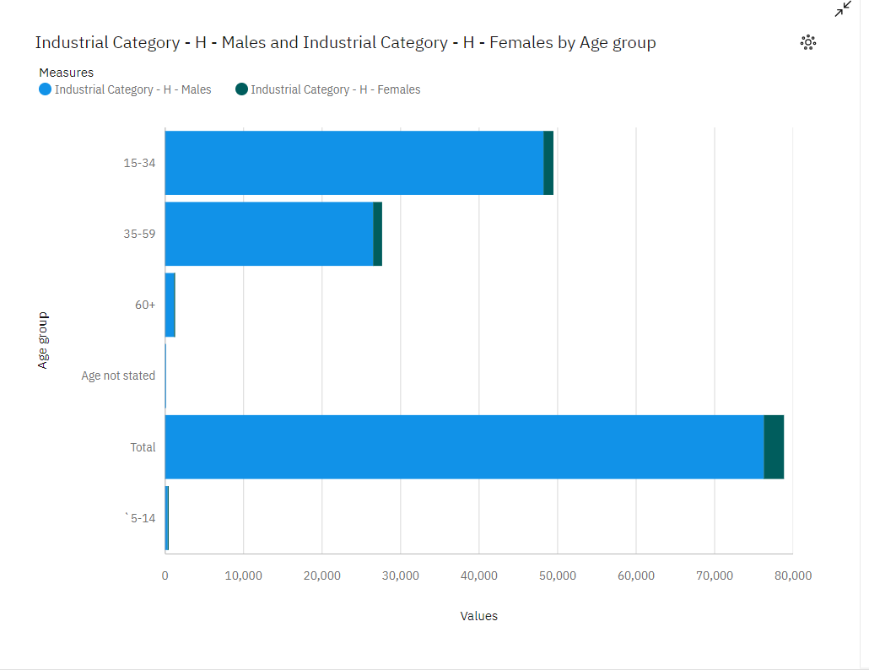

**FINDINGS:**

* Workers with age group between [15-34] are the highest among all the workers in industrial category-H
* Workers with age group between [60+] are the lowest among all the workers in industrial category-H.

**INDUSTRIAL CATEGORIES –I:**

Accommodation and food service activities in marginal areas are essential for the well-being of residents and for attracting tourists and travelers to these often remote or underserved regions. These activities provide lodging and dining options, contributing to the local economy and promoting tourism.

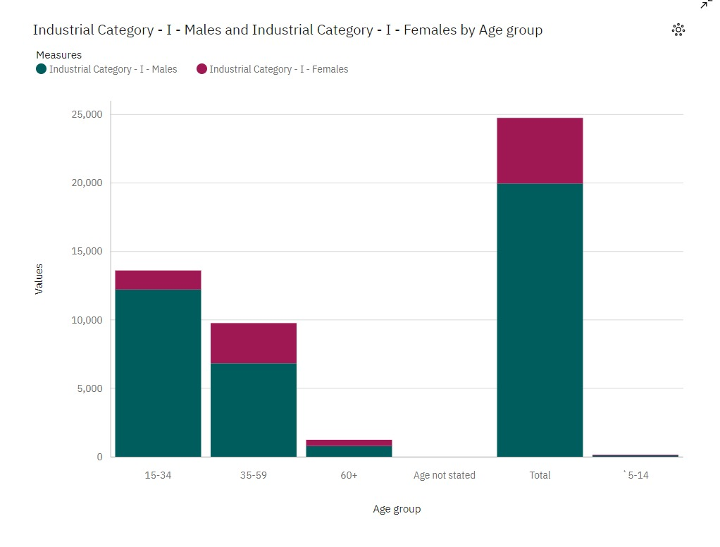

**FINDINGS:**

* Workers with age group between [15-34] are the highest among all the workers in industrial category-H
* Workers with age group between [60+] are the lowest among all the workers in industrial category-H.

**The code for the analysis of the dataset using python library is as follows:**

**CODE:**

import numpy as np # linear algebra

import pandas as pd # data processing, CSV file I/O (e.g. pd.read_csv)

import matplotlib.pyplot as plt

from subprocess import check_output

print(check_output(["ls", "../content"]))

# Any results you write to the current directory are saved as output.

file ="../content/all.csv"

df=pd.read_csv(file,sep=",")

temp = df.groupby('Area Name').sum()

df2=pd.DataFrame(np.array(temp[['X5...14.years', 'X15...59.years','X60.years.and.above..Incl..A.N.S..']]),columns=['X5...14.years','X15...59.years','X60.years.and.above..Incl..A.N.S..'],index=temp.index)

df2.plot.barh(figsize=(12,8),stacked=True,title="Areaname wise age groups")

**OUTPUT:**

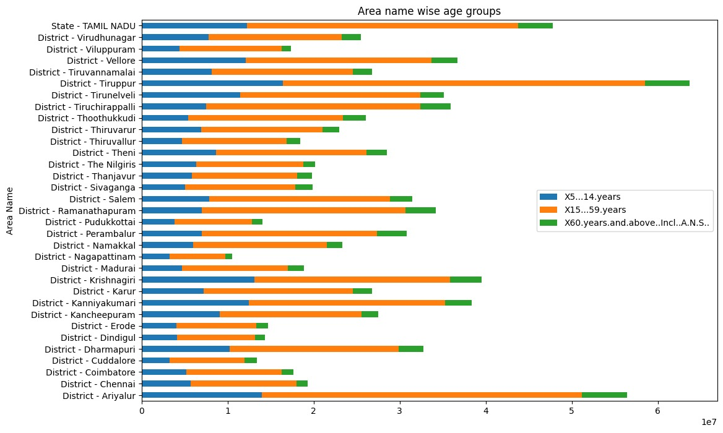

**CONCLUSION:**

The analysis of the data set shows that Agriculture being dominating the nature of employment of the population in Viluppuram. The towns where agriculture is not showing up population’s percentage is increasing in Marginal Work. This means that there has to be some way to motivate agriculture in these towns to so as to engage the population employed throughout the year.This overall analysis shows that workers with age group between [5-19] known as child labours are engaged mostly in industrial categories-c [manufacturing].